LINEAR REGRESSION

1.**Supervised learning methods:** It contains past data with labels which are then used for building the model.

* **Regression**: The output variable to be predicted is *continuous*in nature, e.g. scores of a student, diamond prices, etc.
* **Classification**: The output variable to be predicted is *categorical*in nature, e.g.classifying incoming emails as spam or ham, Yes or No, True or False, 0 or 1.
* Simple Linear Regression
* Linear regression is a quiet and the simplest statistical regression method used for predictive analysis in machine learning. Linear regression shows the linear relationship between the independent(predictor) variable i.e. X-axis and the dependent(output) variable i.e. Y-axis, called linear regression*.*If there is a single input variable **X**(dependent variable), such linear regression is called ***simple linear regression***.
* 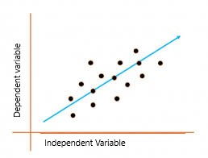

## What is the best fit line?

In simple terms, the best fit line is a line that fits the given scatter plot in the best way. Mathematically, the best fit line is obtained by minimizing the Residual Sum of Squares(RSS).

* **Cost Function for Linear Regression**
* The [cost function](https://www.analyticsvidhya.com/blog/2021/03/data-science-101-introduction-to-cost-function/) helps to work out the optimal values for B0 and B1, which provides the best fit line for the data points.
* In Linear Regression, generally **Mean Squared Error (MSE)** cost function is used, which is the average of squared error that occurred between the **ypredicted** and **yi**.
* We calculate MSE using simple linear equation y=mx+b:
* 
* Using the MSE function, we’ll update the values of B0 and B1 such that the MSE value settles at the minima.  These parameters can be determined using the gradient descent method such that the value for the cost function is minimum.

**Gradient Descent for Linear Regression**

Gradient Descent is one of the optimization algorithms that optimize the cost function(objective function) to reach the optimal minimal solution.

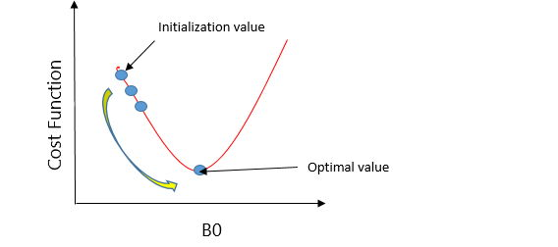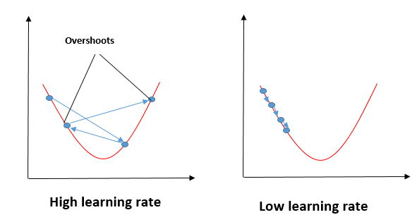

## Evaluation Metrics for Linear Regression

The strength of any linear regression model can be assessed using various evaluation metrics. These evaluation metrics usually provide a measure of how well the observed outputs are being generated by the model.

The most used metrics are,

1. Coefficient of Determination or R-Squared (R2)
2. Root Mean Squared Error (RMSE) and Residual Standard Error (RSE)

### 1. Coefficient of Determination or R-Squared (R2)

R-Squared is a number that explains the amount of variation that is explained/captured by the developed model. It always ranges between 0 & 1 . Overall, the higher the value of R-squared, the better the model fits the data.

### 2. Root Mean Squared Error

The Root Mean Squared Error is the square root of the variance of the residuals. It specifies the absolute fit of the model to the data i.e. how close the observed data points are to the predicted values